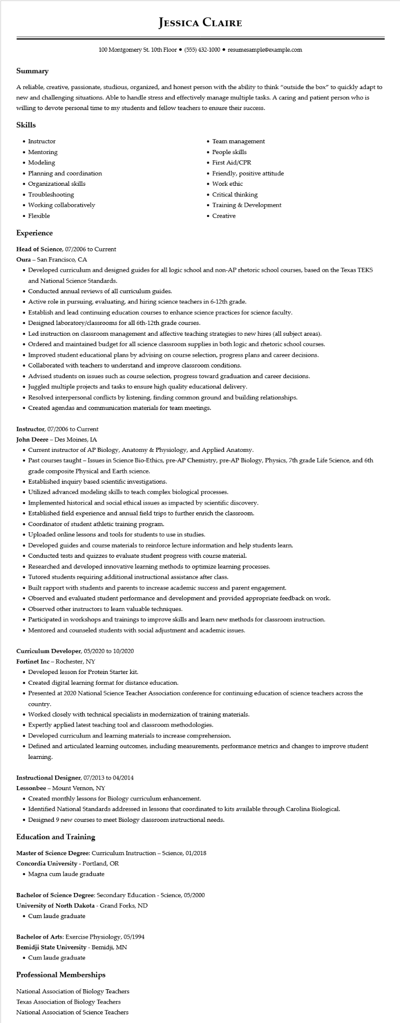
JESSICA CLAIRE
100 Montgomery St. 10th Floor⚫ (555) 432-1000⚫ resumesample@example.com
Summary
A reliable, creative, passionate, studious, organized, and honest person with the ability to think "outside the box" to quickly adapt to new and challenging situations. Able to handle stress and effectively manage multiple tasks. A caring and patient person who is willing to devote personal time to my students and fellow teachers to ensure their success.
Skills
• Instructor
• Mentoring
• Modeling
• Planning and coordination
• Organizational skills
• Troubleshooting
• Working collaboratively
• Flexible
Experience
Head of Science, 07/2006 to Current
Oura - San Francisco, CA
• Team management
• People skills
• First Aid/CPR
• Friendly, positive attitude
• Work ethic
• Critical thinking
• Training & Development
• Creative
• Developed curriculum and designed guides for all logic school and non-AP rhetoric school courses, based on the Texas TEKS and National Science Standards.
• Conducted annual reviews of all curriculum guides.
• Active role in pursuing, evaluating, and hiring science teachers in 6-12th grade.
• Establish and lead continuing education courses to enhance science practices for science faculty.
• Designed laboratory/classrooms for all 6th-12th grade courses.
• Led instruction on classroom management and affective teaching strategies to new hires (all subject areas).
• Ordered and maintained budget for all science classroom supplies in both logic and rhetoric school courses.
• Improved student educational plans by advising on course selection, progress plans and career decisions.
• Collaborated with teachers to understand and improve classroom conditions.
• Advised students on issues such as course selection, progress toward graduation and career decisions.
• Juggled multiple projects and tasks to ensure high quality educational delivery.
• Resolved interpersonal conflicts by listening, finding common ground and building relationships.
• Created agendas and communication materials for team meetings.
Instructor, 07/2006 to Current
John Deere - Des Moines, IA
• Current instructor of AP Biology, Anatomy & Physiology, and Applied Anatomy.
• Past courses taught – Issues in Science Bio-Ethics, pre-AP Chemistry, pre-AP Biology, Physics, 7th grade Life Science, and 6th grade composite Physical and Earth science.
• Established inquiry based scientific investigations.
• Utilized advanced modeling skills to teach complex biological processes.
• Implemented historical and social ethical issues as impacted by scientific discovery.
• Established field experience and annual field trips to further enrich the classroom.
• Coordinator of student athletic training program.
• Uploaded online lessons and tools for students to use in studies.
• Developed guides and course materials to reinforce lecture information and help students learn.
• Conducted tests and quizzes to evaluate student progress with course material.
• Researched and developed innovative learning methods to optimize learning processes.
• Tutored students requiring additional instructional assistance after class.
• Built rapport with students and parents to increase academic success and parent engagement.
• Observed and evaluated student performance and development and provided appropriate feedback on work.
• Observed other instructors to learn valuable techniques.
• Participated in workshops and trainings to improve skills and learn new methods for classroom instruction.
• Mentored and counseled students with social adjustment and academic issues.
Curriculum Developer, 05/2020 to 10/2020
Fortinet Inc - Rochester, NY
• Developed lesson for Protein Starter kit.
• Created digital learning format for distance education.
• Presented at 2020 National Science Teacher Association conference for continuing education of science teachers across the country.
• Worked closely with technical specialists in modernization of training materials.
• Expertly applied latest teaching tool and classroom methodologies.
• Developed curriculum and learning materials to increase comprehension.
• Defined and articulated learning outcomes, including measurements, performance metrics and changes to improve student learning.
Instructional Designer, 07/2013 to 04/2014
Lessonbee - Mount Vernon, NY
• Created monthly lessons for Biology curriculum enhancement.
• Identified National Standards addressed in lessons that coordinated to kits available through Carolina Biological.
• Designed 9 new courses to meet Biology classroom instructional needs.
Education and Training
Master of Science Degree: Curriculum Instruction - Science, 01/2018 Concordia University - Portland, OR
• Magna cum laude graduate
Bachelor of Science Degree: Secondary Education - Science, 05/2000 University of North Dakota - Grand Forks, ND
• Cum laude graduate
Bachelor of Arts: Exercise Physiology, 05/1994
Bemidji State University - Bemidji, MN
• Cum laude graduate
Professional Memberships
National Association of Biology Teachers
Texas Association of Biology Teachers National Association of Science Teachers

